Traceability NC-functions in 840 D G-Code (DRAFT)
Julio Garrido Campos (jgarri@uvigo.es)
Vigo University

get_time()

Siemens840D → Could translate directly into a write operation dumping (WRITE code o Procedure) into a LOG file the appropriate text, and any of the following 840D Variables (CNC internal variables) according with the standard definition of the function:

$A_YEAR $A_MONTH $A_DAY $A_HOUR $A_MINUTE $A_SECOND $A_MSECOND.

Validated and tested example code :
WRITE(ERROR,"LOGFILE", "WS2 START TIME :" << $A_HOUR << ":" << $A_MINUTE << ":" << $A_SECOND << ":" << $A_MSECOND )

(Using the write function or any external-defined file writing procedure)

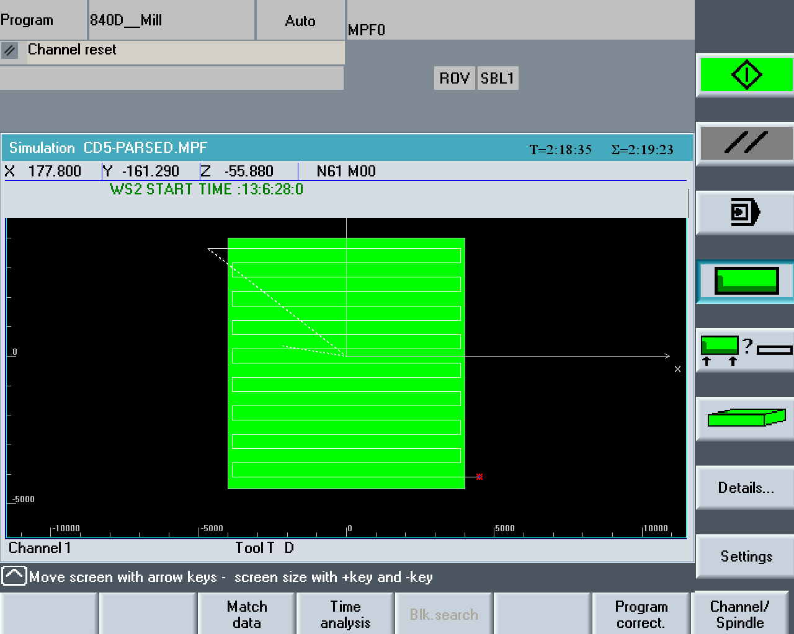

(Sinutrain 840 Screenshot)

start_getting_max_deviaton_along_toolpath()

Siemens840D → Could be translated with the aid of a Siemens Synchronous Motion Action code, using several user variables (R parameters) to store user-defined values.

In the examples, R[1], R[2],R[3] have been used to store X,Y,Z positions of the measured value as given by the encoders variables: $VA_IM[X], $VA_IM[Y] & $VA_IM[Z]

R[5], used to store the actual max deviation path (following error), calculated as:
SQRT( POT($VA_LAG_ERROR[X])+POT($VA_LAG_ERROR[Y])^2+POT($VA_LAG_ERROR[Z])))

For each tool path segments, during its interpolation cycles, the previously stored R[5] value is compared with the new calculated deviation value, and if it is greater, R[5] and X,Y,Z positions are updated and recorded. This is done with the following sample code:

ID=1 WHENEVER ($R[5]<SQRT(POT($VA_LAG_ERROR[X])+POT($VA_LAG_ERROR[Y])+POT($VA_LAG_ERROR[Z]))) DO TCICLO

1. ID=1, identifies the synchronous action as number 1, to be cancelled with the corresponding stop function. WHENEVER is the vocabulary word to indicate that that the action alter DO word should be performed each time the condition (in green is fulfilled)

2. TCICLO is a procedure/subroutine, programmed to store the current variables in the corresponding R-Parameters.

3. After each G-code block corresponding to a tool path segment and before the next motion G-code, recorded values are DUMPED to the log File (1 value per segment), via a WRITE command and the used variables (R-parameters) are reset to 0 to prepare the measure of the next tool path segment deviation value

Validated and Tested example code (software tested, so no ability to obtain non cero $VA_LAG_ERROR[]):

G2X-27.299979Y-90.799979Z-84.74075CR=38.608
WRITE (ERROR,"LOGFILE","SEGMENT MAX DEVIATION VALUE :" << R[5] << "POSITION: X" << R[1] << “ Y ” << R[2] << “ Z “ << R[3])
R[1]=0 R[2]=0 R[3]=0 R[4]=0 R[5]=0
MSG("SEGMENT-1 DEVIATION VALUE RECORDED")
G1X-90.799979Y-27.299979
WRITE (ERROR,"LOGFILE","SEGMENT MAX DEVIATION VALUE : ...")
R[1]=0 R[2]=0 R[3]=0 R[4]=0 R[5]=0

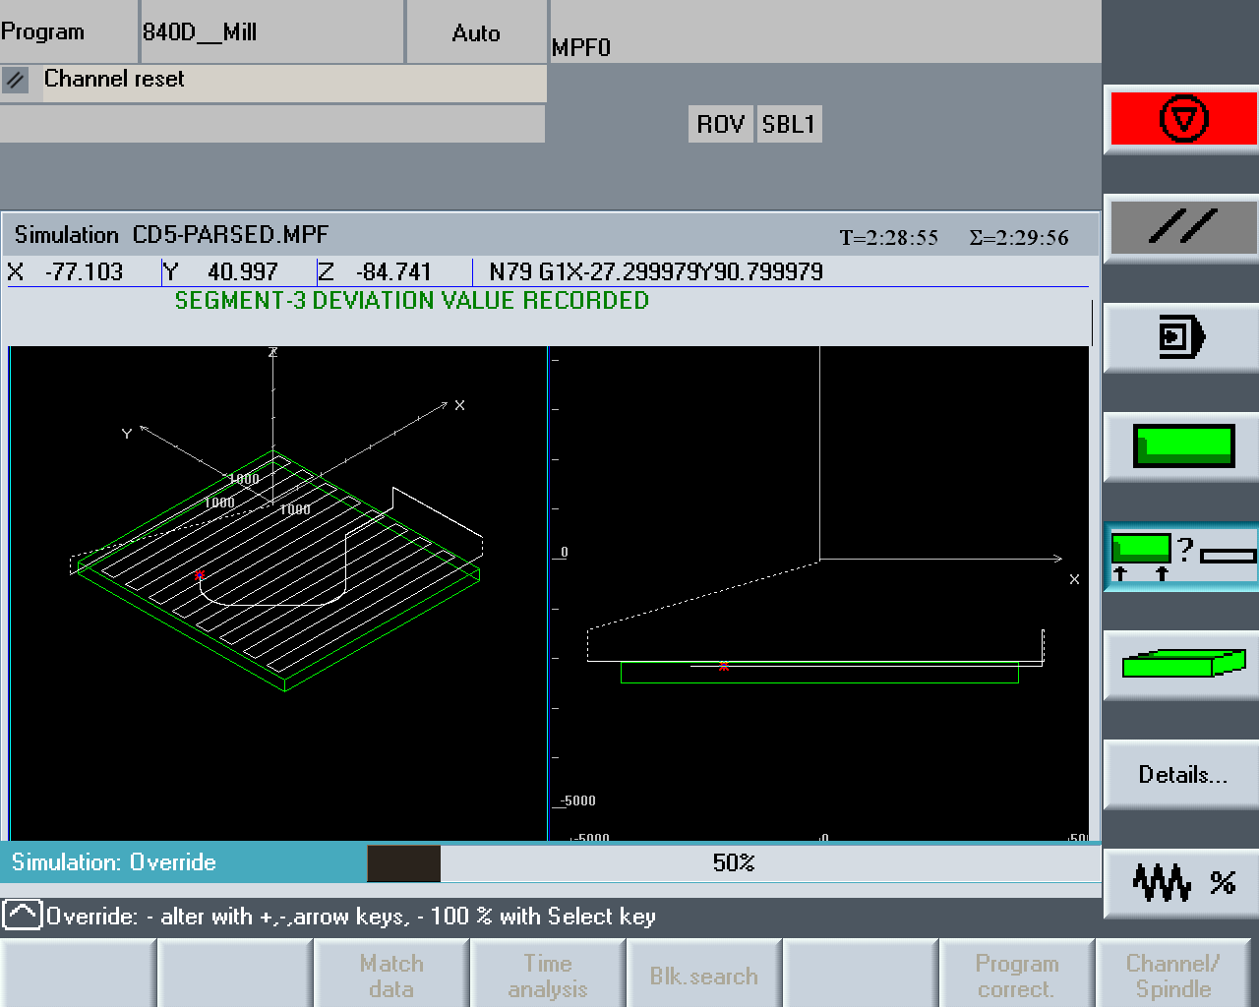

4. It would be necessary to add AP-238 information in the log to macth these values with the corresponding Ap-238 toolpath geometry.

stop_getting_max_deviaton_along_toolpath()

Siemens840D → Could translate directly into cancelling the previously started synchronous action

CANCEL (ID NUMBER)

Sample Code executed in Sinutrain Sinumerik 840d.

;Sample Program (with M00 inserted to pause simulation at several points …)
;AP-238 STEP-NC MAIN PROGRAM
;N01 EXTERN WSSPINDL( INT, REAL )
;N02 EXTERN WSTOOL( INT )
N03 DEF INT ERROR
; VARIABLE INITIALIZATION
N04 R[1]=0 R[2]=0 R[3]=0 R[4]=0 R[5]=0
N10 T="PF25"
N10 G17 G40 G53 G90
N11 MSG("TOOLCHANGEBEGINNING ")
N12 MSG("TOOLCHANGEEND ")
N13 MSG("FACE TOP OF PART")
N14 MSG("BLANK STATEMENT for NC_COMPENSATION ")
N15 MSG("")
N16 M00
; Workingstep 1: line 33 WS 1
;N15 WSMODEON
;N17 WSTOOL( 1 )
N17 G70
;N19 WSSPINDL( 3, 2000.00 )
;N20 WS_FLOOD
N18 G0X0Y0Z-2.54
N19 X-184.15Y143.51Z-55.88
N20 Z-80.772
N21 G1X-152.4F1016
N22 X152.4
N23 Y124.46
N24 X-152.4
N25 Y105.41
N26 X152.4
N27 Y86.36
N28 X-152.4
N29 Y67.31
N30 X152.4Y67.31
N31 Y48.26
N32 X-152.4Y48.26
N33 Y29.21
N34 X152.4Y29.21
N35 Y10.16
N36 X-152.4
N37 Y-8.89
N38 X152.4Y-8.89
N39 Y-27.94
N40 X-152.4Y-27.94
N41 Y-46.99
N42 X152.4
N43 Y-66.04
N44 X-152.4Y-66.04
N45 Y-85.09
N46 X152.4
N47 Y-104.14
N48 X-152.4
N49 Y-123.19
N50 X152.4
N51 Y-142.24
N52 X-152.4
N53 Y-161.29
N54 X152.4
N55 X177.8
N56 G0Z-55.88

; Workingstep: line 123 WS 2

; WRITE IN LOG FILE WS3 START TIME
; WRITE COMMAND (N59)
N57 WRITE(ERROR,"LOGFILE", "WS2 START TIME :" << $A_HOUR << ":" << $A_MINUTE << ":" << $A_SECOND << ":" << $A_MSECOND )
; Display The log message
N58 MSG("WS2 START TIME :" << $A_HOUR << ":" << $A_MINUTE << ":" << $A_SECOND << ":" << $A_MSECOND )
; STOP AFTER TO PAUSE SIMULATION
N59 M00
N61 MSG("EXECUTING TOOLPATH 1 - TP4")
; WS2 TOOLPATH 1 POLYLINE (TP4)
N62 X175.980235Y-18.319722
N63 Z-82.20075
N64 MSG("EXECUTING TOOLPATH 2 - TP5")
; WS2 TOOLPATH 2 POLYLYNE (TP5)
N65 G1Z-84.74075F1016
N66 X99.780235
N67 X90.799979Y-27.299979
N68 X27.299979Y-90.799979
; WS3 TOOLPATH 3 COMPOSITE CURVE (TP6)
; START MONITORING MAX DEVIATION POSITION ALONG TOOLPATH
N69 MSG("ACTIVATING MONITORING OF MAX DEVIATION ALONG TOOLPATH for TP6")
; COMO LLAMADA A CICLO
N69 ID=1 WHENEVER ($R[5]<SQRT(POT($VA_LAG_ERROR[X])+POT($VA_LAG_ERROR[Y])+POT($VA_LAG_ERROR[Z]))) DO TCICLO

N70 G2X-27.299979Y-90.799979Z-84.74075CR=38.608
; EJEMPLO PARA EL LOG
N71 WRITE (ERROR,"LOGFILE","SEGMENT MAX DEVIATION VALUE :" << R[5] << "POSITION" << $VA_IM[X] << $VA_IM[Y] << $VA_IM[Z])
; EJEMPLO DE SALIDA POR PANTALLA
N72 MSG("SEGMENT-1 DEVIATION VALUE RECORDED")
N73 G1X-90.799979Y-27.299979
N74 WRITE (ERROR,"LOGFILE","SEGMENT MAX DEVIATION VALUE : ...")
N75 R[1]=0 R[2]=0 R[3]=0 R[4]=0 R[5]=0
N76 MSG("SEGMENT-2 DEVIATION VALUE RECORDED")
N77 G2X-90.799979Y27.299979Z-84.74075CR=38.608
N78 WRITE (ERROR,"LOGFILE","SEGMENT MAX DEVIATION VALUE : ...")
N79 R[1]=0 R[2]=0 R[3]=0 R[4]=0 R[5]=0
N80 MSG("SEGMENT-3 DEVIATION VALUE RECORDED")
N81 G1X-27.299979Y90.799979
N82 WRITE (ERROR,"LOGFILE","SEGMENT MAX DEVIATION VALUE : ...")
N83 R[1]=0 R[2]=0 R[3]=0 R[4]=0 R[5]=0
N84 MSG("SEGMENT-4 DEVIATION VALUE RECORDED")
N85 G2X27.299979Y90.799979Z-84.74075CR=38.608
N86 WRITE (ERROR,"LOGFILE","SEGMENT MAX DEVIATION VALUE : ...")
N87 R[1]=0 R[2]=0 R[3]=0 R[4]=0 R[5]=0
N88 MSG("SEGMENT-5 DEVIATION VALUE RECORDED")
N89 G1X90.799979Y27.299979
N90 WRITE (ERROR,"LOGFILE","SEGMENT MAX DEVIATION VALUE : ...")
N91 R[1]=0 R[2]=0 R[3]=0 R[4]=0 R[5]=0
N92 MSG("SEGMENT-6 DEVIATION VALUE RECORDED")
N93 X99.780235Y18.319722
N94 WRITE (ERROR,"LOGFILE","SEGMENT MAX DEVIATION VALUE : ...")
N95 R[1]=0 R[2]=0 R[3]=0 R[4]=0 R[5]=0
N96 MSG("SEGMENT-7 DEVIATION VALUE RECORDED")
N97 X175.980235
N98 WRITE (ERROR,"LOGFILE","SEGMENT MAX DEVIATION VALUE : ...")
N99 R[1]=0 R[2]=0 R[3]=0 R[4]=0 R[5]=0
N100 MSG("SEGMENT-8 DEVIATION VALUE RECORDED")
; STOP MONITORING MAX DEVIATION POSITION ALONG TOOLPATH
N101 MSG ("TP6 END AND STOP TOOLPATH MONITRING")
N102 CANCEL(1)
N103 M00
N105 MSG("COMPLETING THE REST OF WORKINGSTEP 2")
N106 G0X166.999979Y-9.339466
N107 G1X90.799979F1016
N108 X81.819722Y-18.319722
N109 X18.319722Y-81.819722
N110 G2X-18.319722Y-81.819722Z-84.74075CR=25.908
N111 G1X-81.819722Y-18.319722
N112 G2X-81.819722Y18.319722Z-84.74075CR=25.908
N113 G1X-18.319722Y81.819722
N114 G2X18.319722Y81.819722Z-84.74075CR=25.908
N115 G1X81.819722Y18.319722
N116 X90.799979Y9.339466
N117 X166.999979
N118 G0X158.019722Y-0.35921
N119 G1X81.819722F1016
N120 X72.839466Y-9.339466
N121 X9.339466Y-72.839466
N122 G2X-9.339466Y-72.839466Z-84.74075CR=13.208
N123 G1X-72.839466Y-9.339466
N124 G2X-72.839466Y9.339466Z-84.74075CR=13.208
N125 G1X-9.339466Y72.839466
N126 G2X9.339466Y72.839466Z-84.74075CR=13.208
N127 G1X72.839466Y9.339466
N128 X81.819722Y0.35921
N129 X158.019722
N130 G0X175.980235Y-18.319722
N131 Z-88.9635
N132 G1X99.780235F1016
N133 X90.799979Y-27.299979
N134 X27.299979Y-90.799979
N135 G2X-27.299979Y-90.799979Z-88.9635CR=38.608
N136 G1X-90.799979Y-27.299979
N137 G2X-90.799979Y27.299979Z-88.9635CR=38.608
N138 G1X-27.299979Y90.799979
N139 G2X27.299979Y90.799979Z-88.9635CR=38.608
N140 G1X90.799979Y27.299979
N141 X99.780235Y18.319722
N142 X175.980235
N143 G0X166.999979Y-9.339466
N144 G1X90.799979F1016
N145 X81.819722Y-18.319722
N146 X18.319722Y-81.819722
N147 G2X-18.319722Y-81.819722Z-88.9635CR=25.908
N148 G1X-81.819722Y-18.319722
N149 G2X-81.819722Y18.319722Z-88.9635CR=25.908
N150 G1X-18.319722Y81.819722
N151 G2X18.319722Y81.819722Z-88.9635CR=25.908
N152 G1X81.819722Y18.319722
N153 X90.799979Y9.339466
N154 X166.999979
N155 G0X158.019722Y-0.35921
N156 G1X81.819722F1016
N157 X72.839466Y-9.339466
N158 X9.339466Y-72.839466
N159 G2X-9.339466Y-72.839466Z-88.9635CR=13.208
N160 G1X-72.839466Y-9.339466
N161 G2X-72.839466Y9.339466Z-88.9635CR=13.208
N162 G1X-9.339466Y72.839466
N163 G2X9.339466Y72.839466Z-88.9635CR=13.208
N164 G1X72.839466Y9.339466
N165 X81.819722Y0.35921
N166 X158.019722
N167 Z-86.4235
N168 G0Z-55.88
; WRITE IN LOG FILE WS3 END TIME
N169 WRITE(ERROR,"LOGFILE", "WS2 END TIME :" << $A_HOUR << ":" << $A_MINUTE << ":" << $A_SECOND << ":" << $A_MSECOND )
; If we want to display a log message
N170 MSG("WS2 END TIME :" << $A_HOUR << ":" << $A_MINUTE << ":" << $A_SECOND << ":" << $A_MSECOND )
N171 M00
N172 MSG("CONTINUE WITH THE REST of WSTEPs")
; Workingstep: line 337 WS 3
N173 X171.958Y0
N174 Z-90.51925
N175 G1Z-93.05925F1016
; PROGRAM STOP FOR THE SIMULATION PART
...

;Sample Technological Cycle

; CALCULATE DEVIATION VALUE
N000 $R[5] = SQRT(POT($VA_LAG_ERROR[X]) + POT($VA_LAG_ERROR[Y]) + POT($VA_LAG_ERROR[Z]))
N030 $R[1]=$AA_IM[X]
N040 $R[2]=$AA_IM[Y]
N050 $R[3]=$AA_IM[Z]
N020 M17

